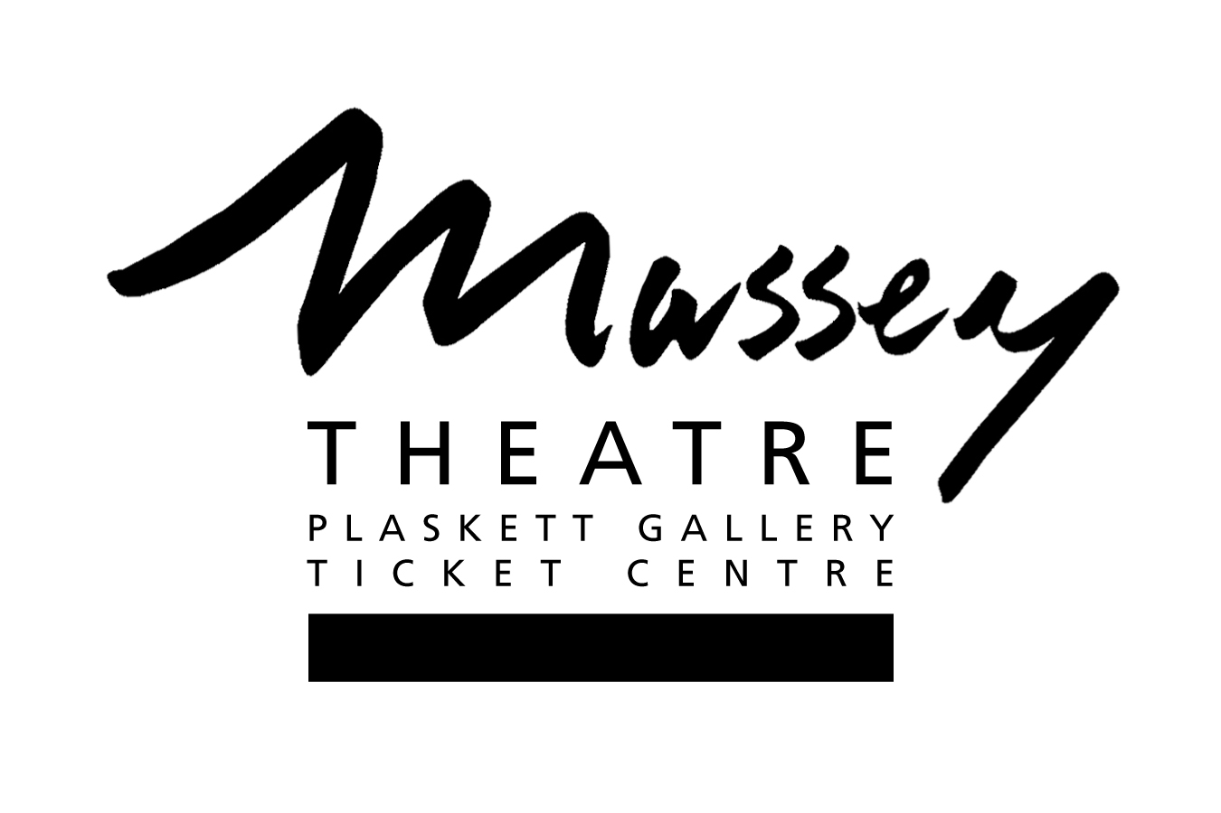

The Massey Helps Program

Program Guidelines

Massey Theatre Society offers a program of free access to theatre space four times per calendar year. The program exists to enhance the activities and initiatives of artistic and community organizations. Applications should reflect projects which are inclusive and open to the community and will assist the presenting organizations in a significant way toward achieving their artistic or charitable aims.

Eligibility

- Any organization or group within the lower mainland of British Columbia who can fulfill the program criteria is invited to apply.
- Priority will be given to New Westminster citizens or organizations when submissions of equal interest are made.
- Existing Massey Theatre rental clients are welcome to apply in support of new initiatives, special events or anniversaries.
- Successful applicants are welcome to apply again in future years however priority may be given to new initiatives or organizations.
- Unsuccessful applicants are welcome to apply again for the same event at future deadlines unless instructed the project was, in fact, ineligible.
- Applications for events which serve to benefit specific political or religious organizations will not be considered.
- Massey Theatre reserves the right to withhold execution of this program at its discretion. In such a case, any eligible applications submitted will be carried forward for review in the next cycle.
- Priority will be given to ticketed events on sale to the general public.

Acknowledgement

The successful applicant will be required to acknowledge The Massey Helps Program at the event and in the programme if available. It will be required that Massey Theatre receives 30 tickets for our own use.

Details of Support

The Massey Helps Program has four opportunities available;

- two within the period of January to June
- two within the period of July to December

The Massey Helps Program provides free rental of the theatre and the equipment and ancillary facilities included with that. Costs associated with technical, front of house and custodial staff will be billed to the recipient. Massey Theatre will provide planning assistance, marketing support, ticketing services, and technical planning to assist in making the event a success. The operation of the theatre, box office, concession, lobby and gallery all remain within the control of Massey Theatre.

DEADLINES: March 31st for events between July and December
September 30th for events between January and June

Applications that are late or incomplete will not be considered.

Before starting to fill in the application form, carefully read the Instructions above.

Ensure you have addressed the following criteria in your application.

Assessment Criteria

The successful application(s) will be for events which aspire to meet the following objectives:

- To showcase or advance the performing arts
- To showcase or advance New Westminster citizens or organizations
- To celebrate or benefit youth
- To support charitable causes, new ventures or fledgling organizations
- To make use of the theatre’s scale, technical capabilities and large seating capacity.

- Organization Full Legal Name: If you have another version of this name for common use, please put in brackets following the registered name. If this is a collaborative project, please identify the lead organization and other partner organizations.

- Contact Person, Name and Position: This is the contact we will enter in our database and use for the duration of the grant cycle process. Please inform us of any changes immediately.

- Organization Mailing Address:
City: Postal Code:

- Telephone: Fax: Email:

- Society Act Incorporation Number:
Is the Society in good standing? Yes No
- Federal Registered Charity Number: (if your organization is not a charity, please leave blank)
- Event Summary: Please provide us with an overview of the event you wish to undertake.

- What is the desired date for the event?

9. Is the date flexible, based on availability?

10. Please provide a brief history or overview of the organization.

11. Please describe the organization’s history with Massey Theatre if it exists.

12. Please outline how receipt of this support will assist the organization in its artistic or charitable aims.

13. Please outline how you will promote the project and describe your past achievement in audience attendance.

14. Please confirm that your event will be a ticketed event. If not, describe your plans.

15. Does your organization see a potential ongoing relationship with Massey Theatre? Please describe.

The recipients of this program are determined by a committee of Massey Theatre Society’s Board of Directors and professional staff.

